EXAM 1 – ISTQB FOUNDATION-21

# Đán án em thiết kế dạng table theo mẫu cô gửi nhé

# CHAPTER 1

# CHAPTER 2

Q3.n**Alpha testing**

**-simulated or actual operational testing at an in-house site not otherwise involved with the software developers (i.e. developers’ site)**

**nBeta testing**

**-operational testing at a site not otherwise involved with the software developers (i.e. testers’ site, their own location)**

**Q6.Early test design**

**+test design finds faults**

**+faults found early are cheaper to fix**

**+most significant faults found first**

**+faults prevented, not built in**

**+no additional effort, re-schedule test design**

**+changing requirements caused by test design**

| A | Performed by customers at their own site |
| --- | --- |
| **B** | Performed by customers at their software developer’s site |
| C | Performed by an independent test team |
| D | Useful to test bespoke software |
| E | Performed as early as possible in the lifecycle |

**Q14.Verification**

**the process of evaluating a system or component to determine whether the products of the given development phase satisfy the conditions imposed at the start of that phase [BS 7925-1]**

**Validation**

**•determination of the correctness of the products of software development with respect to the user needs and requirements [BS 7925-1]**

**Testing**

**•the process of exercising software to verify that it satisfies specified requirements and to detect faults**

| A | Options i,ii,iii,iv are true. |
| --- | --- |
| **B** | ii is true and i,iii,iv are false |
| C | i,ii,iii are true and iv is false |
| D | iii is true and i,ii,iv are false. |

# CHAPTER 3

Q13.**Informal Review (undocumented)**

•widely viewed as useful and cheap (but no one can prove it!) A helpful first step for chaotic organisations.

**Technical Review: (or peer review)**

•includes peer and technical experts, no management participation. Normally documented, fault-finding. Can be rather subjective.

**Decision-making Review:**

•group discusses document and makes a decision about the content, e.g. how something should be done, go or no-go decision, or technical comments

**Walkthrough**

•author guides the group through a document and his or her thought processes, so all understand the same thing, consensus on changes to make

**Inspection:**•formal individual and group checking, using sources and standards, according to generic and specific rules and checklists, using entry and exit criteria, Leader must be trained & certified, metrics required

| A | A. Inspection |
| --- | --- |
| B | B. Walkthrough |
| C | C. Technical Review |
| D | D. Formal Review |

# CHAPTER 4

Q1.**Static (non-execution) → Chương 3**

**•examination of documentation,source code listings, etc.**

**Functional (Black Box)**

**•based on behaviour /functionality of software**

**Structural (White Box)**

**•based on structure of software**

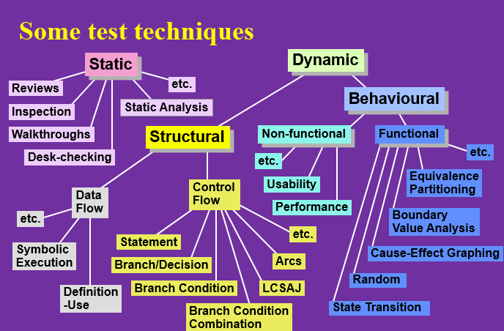

1. Assume postal rates for light letters are: (4.2.1)

$0.25 up to 10 grams.

$0.35 up to 50 grams.

$0.45 up to 75 grams.

$0.55 up to 100 grams.

Which test inputs (in grams) could be selected using equivalence partitioning?

| A | 0, 9, 10, 49, 50, 74, 75, 99, 100 |
| --- | --- |
| **B** | 5, 35, 65, 95, 115 |
| C | 0, 1, 10, 11, 50, 51, 75, 76, 100, 101 |
| D | 5, 25, 35, 45, 55 |

**Q9.Error guessing and fault attacks:** Error guessing is a technique that should always be used as a complement to other more formal techniques.

->B

**Q11.**D

# CHAPTER 5

# CHAPTER 6

Q. 5: A typical commercial test execution tool would be able to perform all of the following

EXCEPT:

A. Generating expected outputs **X**

B. Replaying inputs according to a programmed script

C. Comparison of expected outcomes with actual outcomes

D. Recording test inputs

E. Reading test values from a data file